Java实验3

**学院：信息科学技术学院**

**班级：17软件工程2班**

**姓名：林锦涛**

**学号：1714080902223**

**实验步骤**

**Photoshow.html代码**

**<!DOCTYPE html PUBLIC "-//W3C//DTD XHTML 1.0 Transitional//EN" "http://www.w3.org/TR/xhtml1/DTD/xhtml1-transitional.dtd">**

**<html xmlns="http://www.w3.org/1999/xhtml">**

**<head>**

**<meta http-equiv="Content-Type" content="text/html; charset=utf-8" />**

**<link rel="stylesheet" type="text/css" href="photoshow.css"/>**

**<title>Wall</title>**

**</head>**

**<body>**

**<h1> 照片墙</h1>**

**<div class="pic"><a href="wall图片/03.jpg"><img src="wall图片/03.jpg" width="650" height="360" /></a></div>**

**<div class="pic"><a href="wall图片/01.jpg"><img src="wall图片/01.jpg" width="650" height="360" /></a></div>**

**<div class="pic"><a href="wall图片/02.jpg"><img src="wall图片/02.jpg" width="650" height="360"/></a></div>**

**<div class="pic"><a href="wall图片/04.jpg"><img src="wall图片/04.jpeg" width="650" height="360"/></a></div>**

**</body>**

**</html>**

**Photoshow.css代码**

**@charset "utf-8";**

**h1**

**{**

**font-size: 80px;**

**font-weight: 800;**

**font-style: normal;**

**color: #600;**

**font-family: Verdana, Geneva, sans-serif;**

**text-decoration: blink;**

**text-align: center;**

**}**

**body**

**{**

**background-repeat: no-repeat;**

**background-image: url(wall%E5%9B%BE%E7%89%87/timg%20(1)**

**.jpg)**

**.jpg);**

**float: left;**

**background-position: center;**

**background-size: 1600 1200;**

**background-image: url(wall%E5%9B%BE%E7%89%87/temp.jpg);**

**}**

**.pic {**

**height: auto;**

**width: auto;**

**clear: none;**

**float: left;**

**border: medium solid #603;**

**margin-top: -35px;**

**margin-right: 10px;**

**margin-bottom: 50px;**

**margin-left: 55px;**

**}**

**运行结果：**

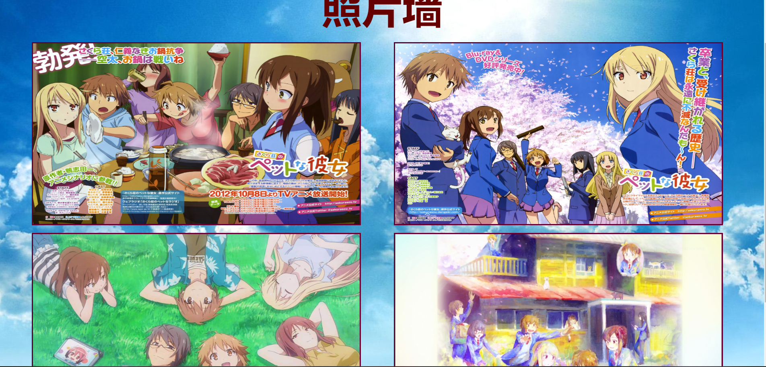

**div.html代码**

**<!DOCTYPE html PUBLIC "-//W3C//DTD XHTML 1.0 Transitional//EN" "http://www.w3.org/TR/xhtml1/DTD/xhtml1-transitional.dtd">**

**<html xmlns="http://www.w3.org/1999/xhtml">**

**<head>**

**<meta http-equiv="Content-Type" content="text/html; charset=utf-8" />**

**<title>DIV层次</title>**

**<style type="text/css">**

**body**

**{**

**background-color: #6BC804;**

**text-align: center;**

**}**

**#d1 {**

**background-color: #579204;**

**height: 180px;**

**width: 520px;**

**margin-top: 150px;**

**margin-right: auto;**

**margin-bottom: auto;**

**margin-left: auto;**

**}**

**#d2{**

**background-color: #FFF;**

**height: 200px;**

**width: 500px;**

**margin-top: -190px;**

**margin-right: auto;**

**margin-bottom: auto;**

**margin-left: auto;**

**background-image: url(wall%E5%9B%BE%E7%89%87/xxt.PNG);**

**}**

**#d3{**

**font-size: 12px;**

**height: 50px;**

**width: 500px;**

**margin: auto;**

**text-align: right;**

**}**

**#d3 a**

**{**

**font-size: 16px;**

**color: #FFF;**

**text-decoration: none;**

**}**

**</style>**

**</head>**

**<body>**

**<div id="d1"></div>**

**<div id="d2"></div>**

**<div id="d3">进惠州学院计算机科学系请<a href="http://cs.hzu.edu.cn">点击进入</a></div>**

**</body>**

**</html>**

**运行结果：**



**flashshop.html代码**

**<!DOCTYPE html PUBLIC "-//W3C//DTD XHTML 1.0 Transitional//EN" "http://www.w3.org/TR/xhtml1/DTD/xhtml1-transitional.dtd">**

**<html xmlns="http://www.w3.org/1999/xhtml">**

**<head>**

**<meta http-equiv="Content-Type" content="text/html; charset=utf-8" />**

**<link rel="stylesheet" type="text/css" href="flashpage.css"/>**

**<title>无标题文档</title>**

**</head>**

**<body>**

**<script src="RevealTrans.js"></script>**

**<div id="idPicShow" class="piccontainer"> </div>**

**<script>**

**var rvt = new revealTrans("idPicShow");**

**rvt.Add("wall图片/柯南1.jpg", "柯南动画", "http://www.iqiyi.com/a_19rrhc0gyd.html?vfm=2008_aldbd");**

**rvt.Add("wall图片/柯南2.jpg", "柯南百科", "https://baike.baidu.com/item/%E5%90%8D%E4%BE%A6%E6%8E%A2%E6%9F%AF%E5%8D%97/3469662?fr=aladdin");**

**rvt.Add("wall图片/柯南3.jpeg", "柯南漫画", "http://www.1kkk.com/manhua675/");**

**rvt.Start();**

**</script>**

**</body>**

**</html>**

**Flashshow.css代码**

**@charset "utf-8";**

**/* CSS Document */**

**#idPicShow{**

**margin: auto;**

**height: 800px;**

**width: 1200px;**

**}**

**RevealTrans.js代码**

**var isIE = (document.all) ? true : false;**

**if (isIE){**

**isIE = navigator.userAgent.indexOf("MSIE 6.0")>0 || navigator.userAgent.indexOf("MSIE 7.0")>0 ||navigator.userAgent.indexOf("MSIE 6.0")>0?true:false;**

**}**

**var $ = function (id) {**

**return "string" == typeof id ? document.getElementById(id) : id;**

**};**

**var Class = {**

**create: function() {**

**return function() { this.initialize.apply(this, arguments); }**

**}**

**}**

**var Extend = function(destination, source) {**

**for (var property in source) {**

**destination[property] = source[property];**

**}**

**}**

**var Bind = function(object, fun) {**

**return function() {**

**return fun.apply(object, arguments);**

**}**

**}**

**var Each = function(list, fun){**

**for (var i = 0, len = list.length; i < len; i++) { fun(list[i], i); }**

**};**

**//ie only**

**var revealTrans = Class.create();**

**revealTrans.prototype = {**

**initialize: function(container, options) {**

**this._img = document.createElement("img");**

**this._a = document.createElement("a");**

**this._timer = null;//计时器**

**this.Index = 0;//显示索引**

**this._onIndex = -1;//当前索引**

**this.SetOptions(options);**

**this.Auto = !!this.options.Auto;**

**this.Pause = Math.abs(this.options.Pause);**

**this.Duration = Math.abs(this.options.Duration);**

**this.Transition = parseInt(this.options.Transition);**

**this.List = this.options.List;**

**this.onShow = this.options.onShow;**

**//初始化显示区域**

**this._img.style.visibility = "hidden";//第一次变换时不显示红x图**

**this._img.style.width = this._img.style.height = "100%"; this._img.style.border = 0;**

**this._img.onmouseover = Bind(this, this.Stop);**

**this._img.onmouseout = Bind(this, this.Start);**

**isIE && (this._img.style.filter = "revealTrans()");**

**this._a.target = "_blank";**

**$(container).appendChild(this._a).appendChild(this._img);**

**},**

**//设置默认属性**

**SetOptions: function(options) {**

**this.options = {//默认值**

**Auto: true,//是否自动切换**

**Pause: 2000,//停顿时间(微妙)**

**Duration: 2,//变换持续时间(秒)**

**Transition: 23,//变换效果(23为随机)**

**List: [],//数据集合,如果这里不设置可以用Add方法添加**

**onShow: function(){}//变换时执行**

**};**

**Extend(this.options, options || {});**

**},**

**Start: function() {**

**clearTimeout(this._timer);**

**//如果没有数据就返回**

**if(!this.List.length) return;**

**//修正Index**

**if(this.Index < 0 || this.Index >= this.List.length){ this.Index = 0; }**

**//如果当前索引不是显示索引就设置显示**

**if(this._onIndex != this.Index){ this._onIndex = this.Index; this.Show(this.List[this.Index]); }**

**//如果要自动切换**

**if(this.Auto){**

**this._timer = setTimeout(Bind(this, function(){ this.Index++; this.Start(); }), this.Duration * 1000 + this.Pause);**

**}**

**},**

**//显示**

**Show: function(list) {**

**if(isIE){**

**//设置变换参数**

**with(this._img.filters.revealTrans){**

**Transition = this.Transition; Duration = this.Duration; apply(); play();**

**}**

**}**

**this._img.style.visibility = "";**

**//设置图片属性**

**this._img.src = list.img; this._img.alt = list.text;**

**//设置链接**

**!!list["url"] ? (this._a.href = list["url"]) : this._a.removeAttribute("href");**

**//附加函数**

**this.onShow();**

**},**

**//添加变换对象**

**Add: function(sIimg, sText, sUrl) {**

**this.List.push({ img: sIimg, text: sText, url: sUrl });**

**},**

**//停止**

**Stop: function() {**

**clearTimeout(this._timer);**

**}**

**};**

**运行结果：**

